*If you are trying to access a virtual desktop, please choose the Desktop tab, as seen in step 6.

- Open your browser and go to mydesktop.uhmc.sunysb.edu. Type your UHMC username and password and click ‘Log On’ to continue.
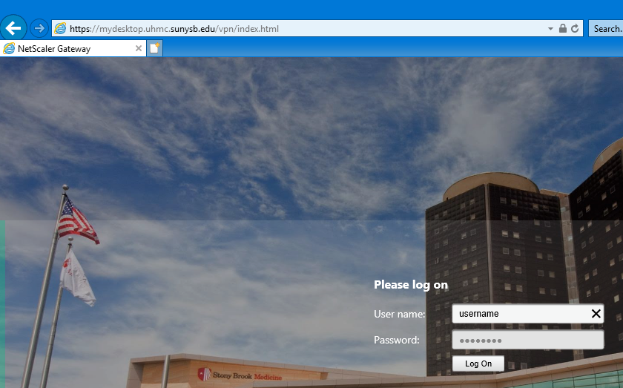

- If logging on for the first time, you may see this message. Choose ‘Install’.
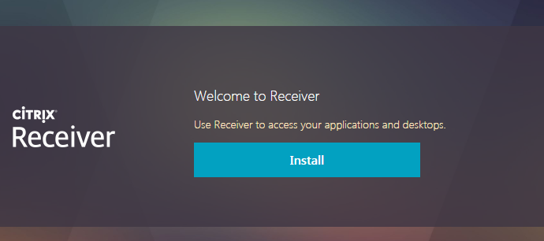
- Then choose ‘Already installed’ from the bottom link.
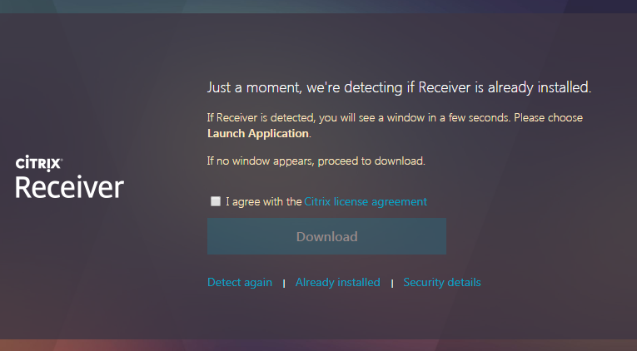

- Once logged in, choose the application that you’d like to launch by clicking on it.
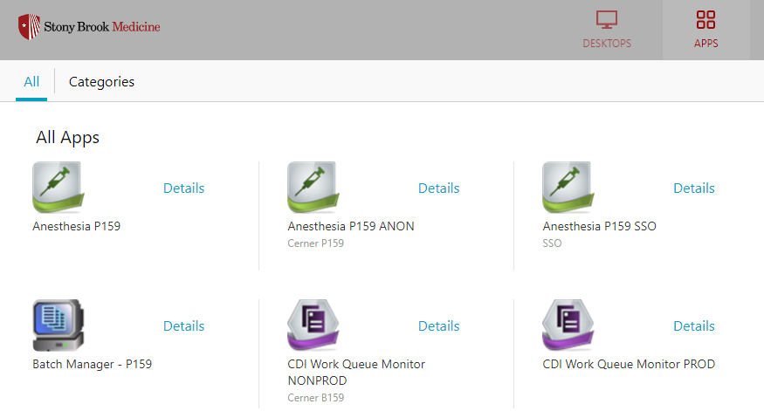

- If you’d like to launch a virtual desktop, choose the ‘Desktops’ button at the top and you will be taken to the desktops you have access to. Launch the desktop by clicking on it.
